Milestone Two

Ryan Manchanthasouk

Southern New Hampshire University

March 31st, 2019

Data Management

Here, the query ALTER TABLE is being used to add a new column to the customer table. The new column’s name is gender, which cannot be null, and is limited to 1 character which would be either M for male or F for female.

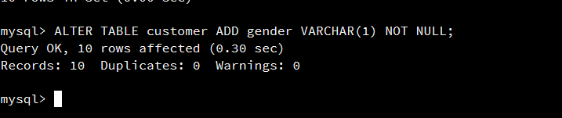

In this next portion, the UPDATE query is being used to give the new column values for the existing data in the customer table. Here the gender column is being updated to ‘M’ for the specific row with customer_id = 1.

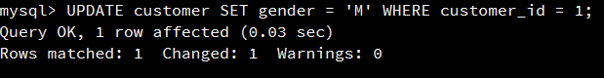

The same query was then used to update the rest of the table. The next portion was the SELECT * FROM query, which lists all the data values from a table. This was used to verify that the data was inserted correctly.

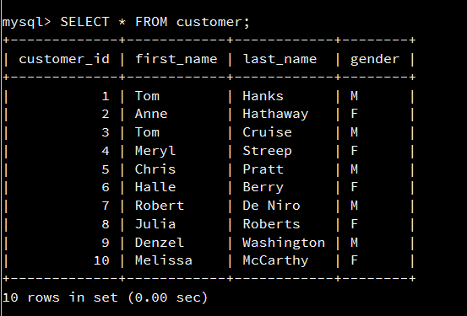

Next, new values are being added to the customer table by using the INSERT INTO query. First, the correct table is chosen, and the columns that are going to be updated are placed in parentheses. Then the corresponding values are input.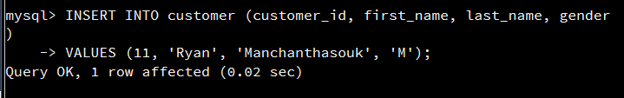

The SELECT * FROM query is used again to verify that the correct values were input in to the customer table, which is in the next screen shot.

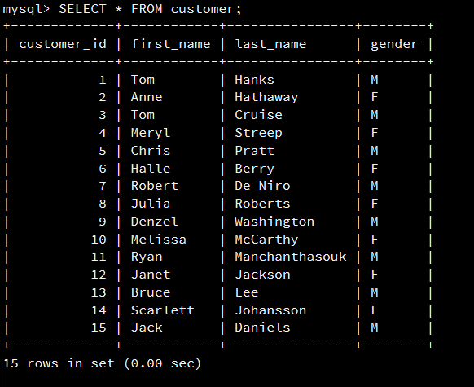

The INSERT INTO query is used again to update the flight table, putting two additional rows of data in.

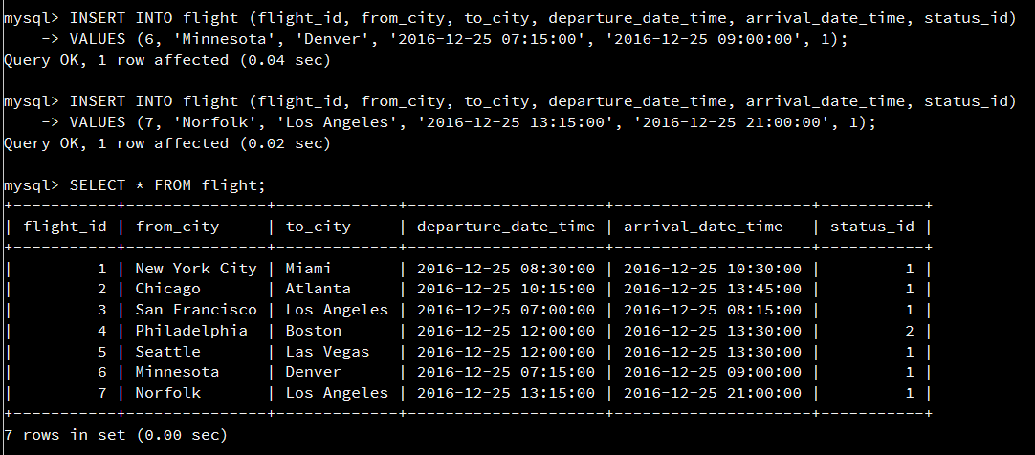

The INSERT INTO query is then used again to update the flight_reservation table.

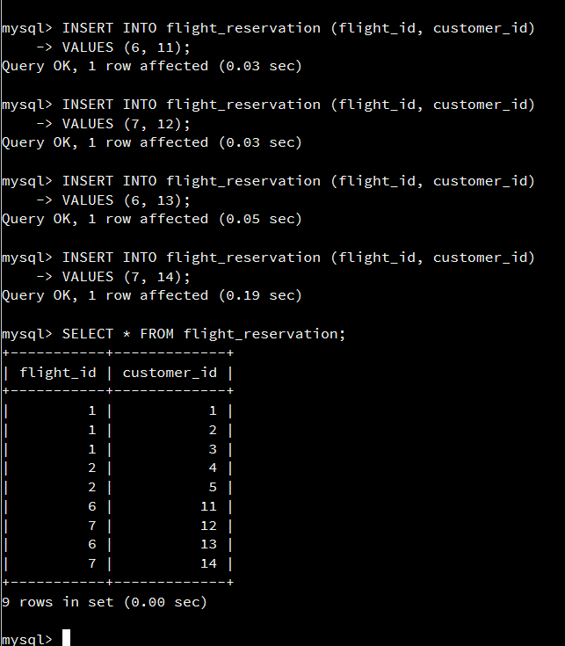

Lastly, the DELETE FROM query is used to delete the flight from Seattle to Las Vegas. The flight’s flight_id was used to delete the data from the table.

